**What is a project?**

A project is …

* a temporary, one-time, coordinated undertaking
* has a definable goal
* has interrelated and dependent activities and tasks
* is finite in duration
* provides a unique product, service or information
* operates under scope, quality, cost and time constraints
* a temporary endeavor undertaken to create a unique product, service, or result

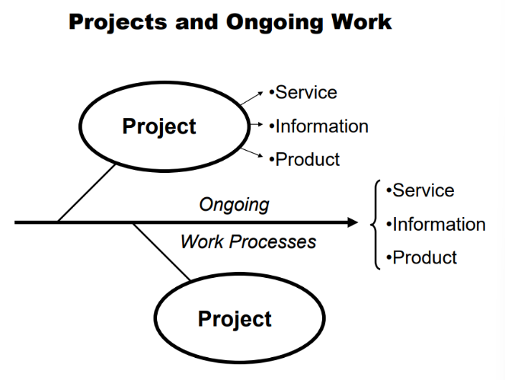

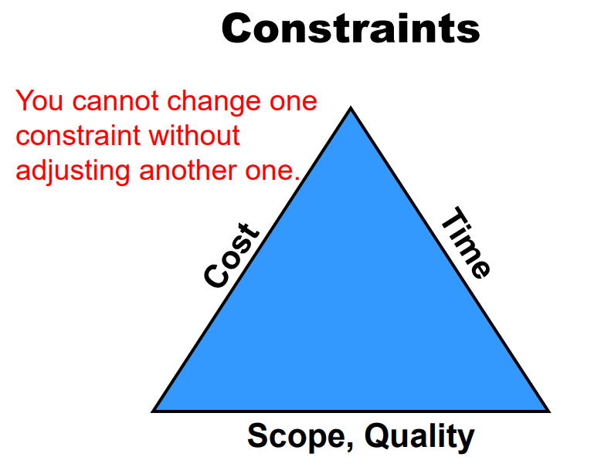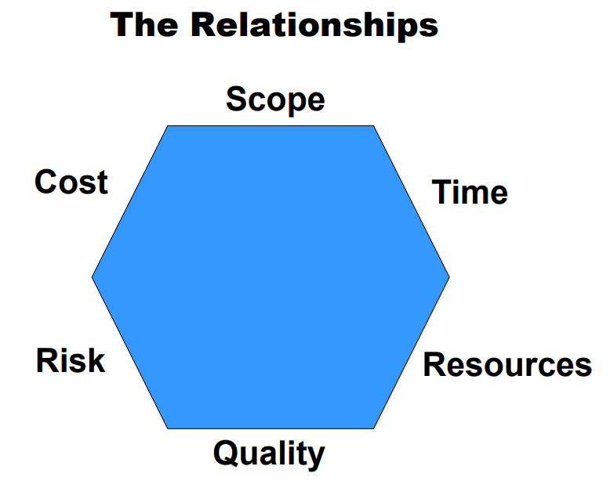

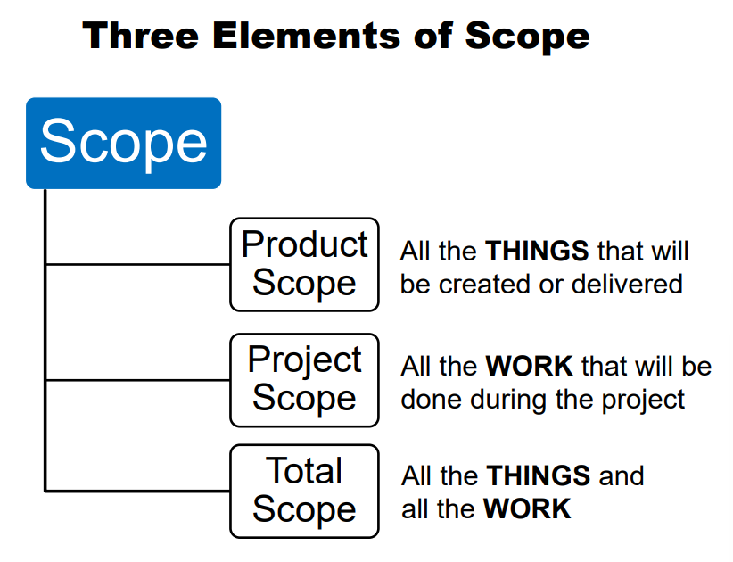

**What is a Project Manager?**

The person assigned by the performing organization to achieve the project objectives.

* Technical Skills
* Project Management Process Skills
* Leadership Skills

The Various Roles of the PM

* Task & Human
* Integrator vs. Technical Expert
* Big Picture & Detail
* Politics
* Projects vs Functions

**What is Project Management?**

The application of knowledge, skills, tools, and techniques to project activities to meet project requirements. Project Management is accomplished through the use of processes such as: initiating, planning, executing, controlling and closing.

* Planning
* Scheduling
* Managing
* Coordinating
* Leading
* Communicating
* Controlling

Process Groups

The Project Management Institute® defines five process groups for completing a project:

* Initiate
* Plan
* Execute
* Monitor and Control
* Close

**Initiating**

Stakeholder

Individuals and organizations that are actively involved in the project or whose interests may be positively or negatively affected as a result of the project execution or project completion. They may also exert influence over the project and its results.

Customer

* One of the overall list of stakeholders.
* Special subset of stakeholder.
* Individual or group that receives the deliverables of the project.

Project Charter

* Agreement between all involved parties
* One location for all overview information
* Definition of the project
* Guide for the project activities

Scope Statement: The description of the project scope, major deliverables, assumptions, and constraints

Stakeholder Analysis

A technique of systematically gathering and analyzing quantitative and qualitative information to determine whose interests should be taken into account throughout the project.

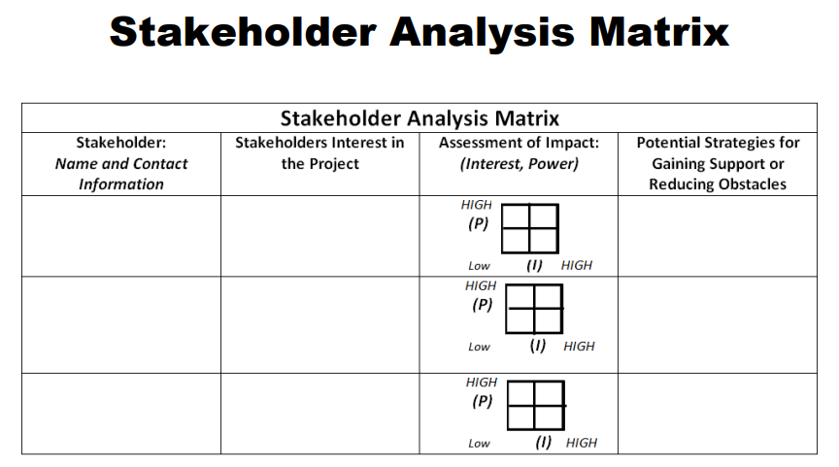

**Planning**

**Risk**

Risks to a Project

* All projects have risks
* It is always best to know upfront
* There are numerous risk analysis tools and methods
* Use at least one

What is “Risk”? An uncertain event or condition that, if it occurs, has a positive or negative effect on a project’s objectives.

Four Steps

* Find the risks
* Analyze the risks
* Develop a risk plan
* Mitigate the risks as they arise

Impact

* How bad will it be if it happens?
* How much will it affect the project?

Probability

* What are the chances it will occur during the project?
* What is the likelihood that something will fail?

Triggers

* Can I see it coming before it hits the project?
* Will I know when the risk has hit the project and is affecting it?

Make Decisions and Take Actions based on Risk Priorities

* Determine which risks will affect your project the most
* Decide which risks are the ones to plan countermeasures for and which to mitigate
* Plan your actions

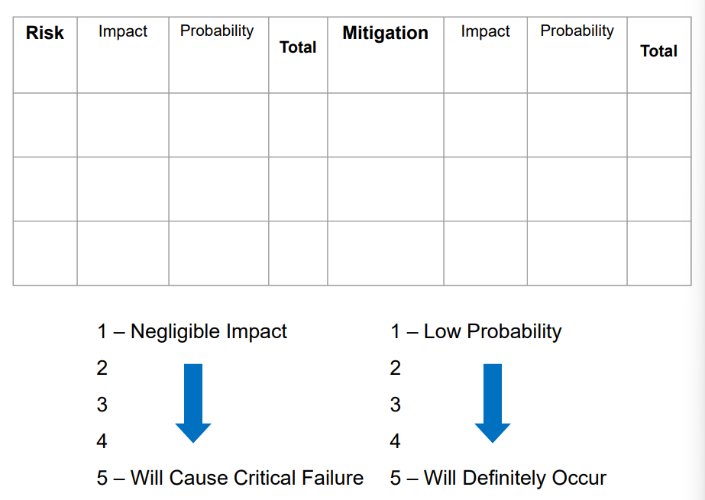

Project Tasks

* It all comes down to individual project tasks
* The project plan is the lay-out of these tasks with times and resources assigned

**WBS**

What is a WBS?

A deliverable-oriented grouping of project elements that organizes and defines the total scope of the project. Each descending level represents an increasingly detailed definition of the project work. Work not in the WBS is outside the scope of the project.

Work Breakdown Structure (WBS)

* A way to plan the tasks
* A way to display the tasks
* A way to communicate the project complexity

Why a WBS?

* Foundation for planning the project
* Project planning is based on the tasks displayed on the WBS
* Provides a detailed illustration of the project
* Defines human resource cost estimates
* Provides clear assignments to project members

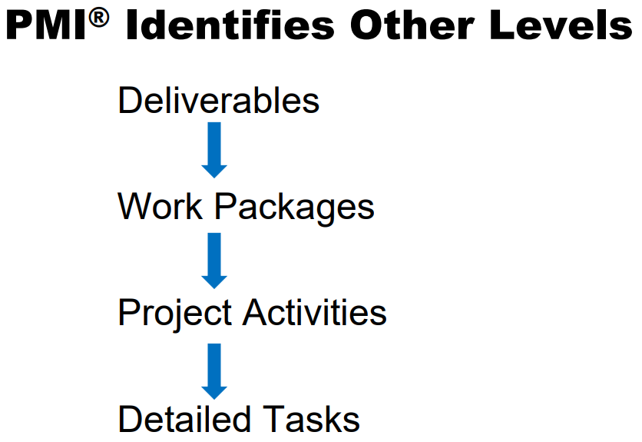

Two Major Schools of Thought

1. Only include Deliverables and Work Packages
2. Include Deliverables, Work Packages, Project Activities, Detailed Tasks

The Project Schedule is constructed from the Detailed Tasks. If you do not list items on the WBS, you still have to list them someplace possibly in a WBS Dictionary or a Task List.

Identify the Tasks

1. First define the deliverables
2. Then identify the tasks that will create or provide those deliverables

Deliverable: Any unique and verifiable product, result, or capability to perform a service that must be produced to complete the process, phase, or project. Often used more narrowly in reference to an external deliverable, which is a deliverable that is subject to approval by the project sponsor or customer.

Project Activity: A component of work performed during the course of a project.

The WBS Will Outline: All Three Ways Scope Is Viewed

* Product Scope: The Things
* Project Scope: The Work
* Scope: The Things and The Work

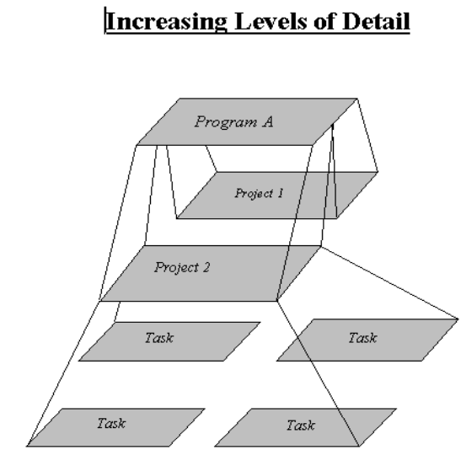

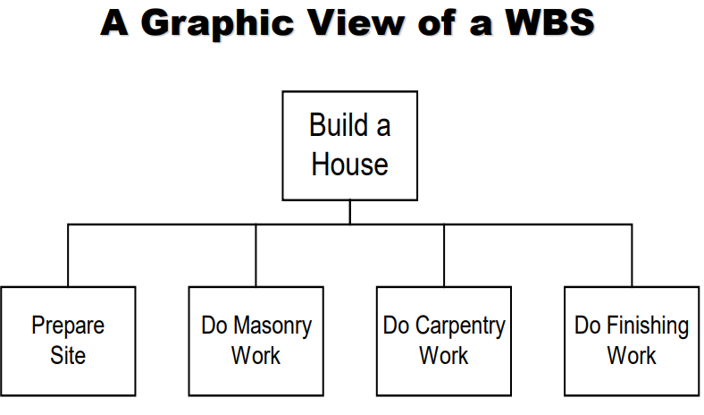 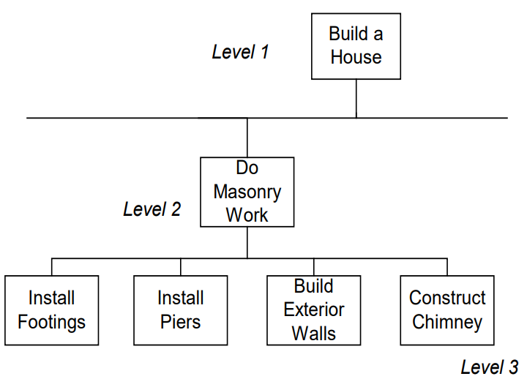

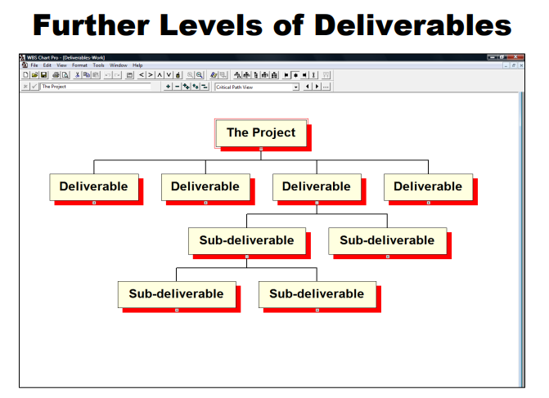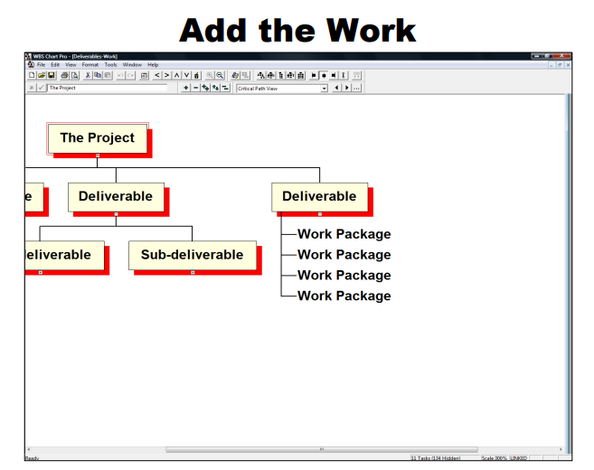

There Are Other Ways

* Activity Based WBS
* Phase Based WBS

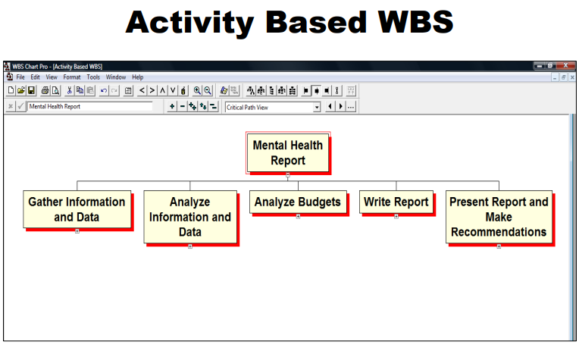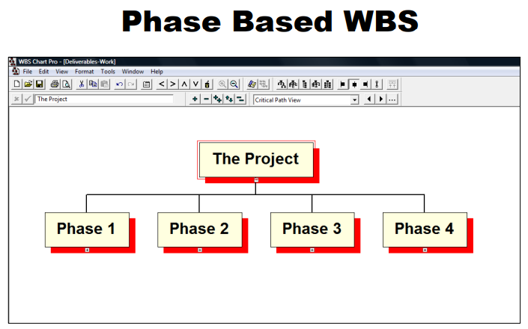

How Detailed?

* Stop at the level where work is in fine enough detail it can be delegated to a person or group
* A rough guideline is 4 – 40 hours
  + No shorter that 4 hour tasks
  + No longer than 40 hour tasks
* This is only a guideline

Detailed Cost Estimate of the Work Required to Complete the Project

The completed WBS is the first opportunity during the Project Plan that detailed estimates of the total amount work and the total cost of the human resource element of the project can be developed. This WBS information will be key in understanding Earned Value Analysis tools.

Two Views of a WBS:

* Chart View
* Outline View

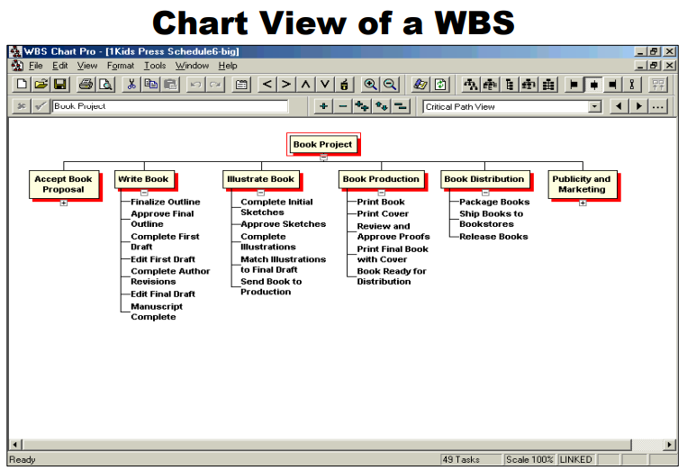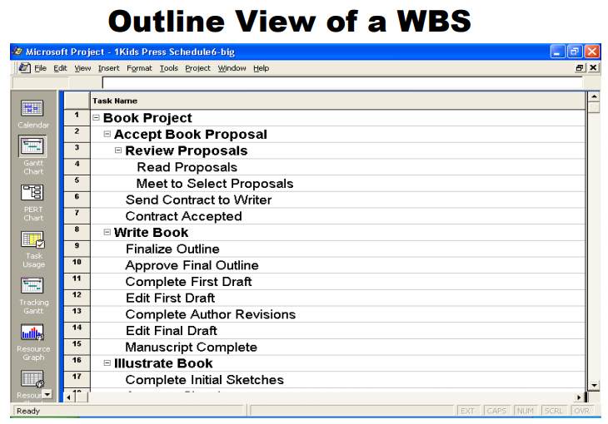

**Scheduling**

The Project Schedule

* Shows the relationship of the project activities and tasks
* Shows the dependencies (which tasks follow other tasks in a logical sequence)

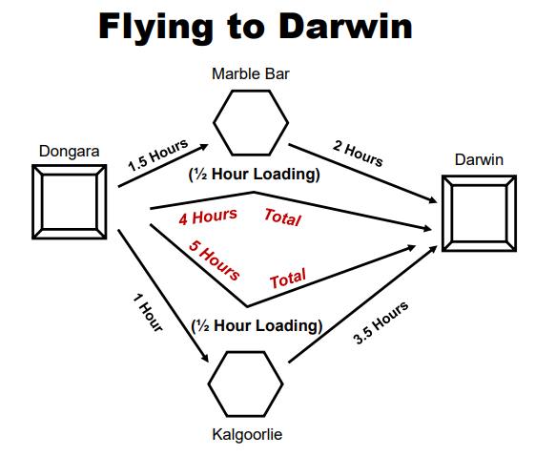

Two Concepts

* Sequential
* Simultaneous

Two More Concepts

* Critical Path
* Float Time

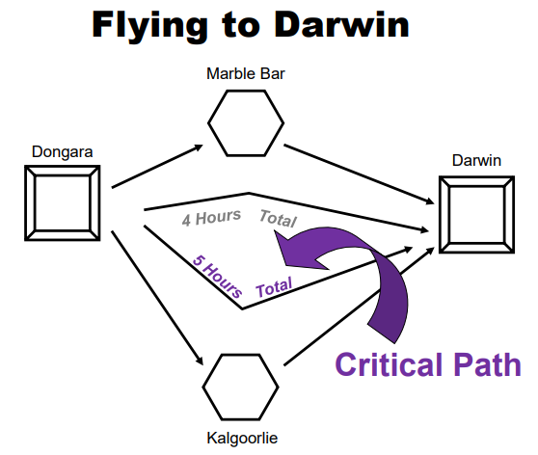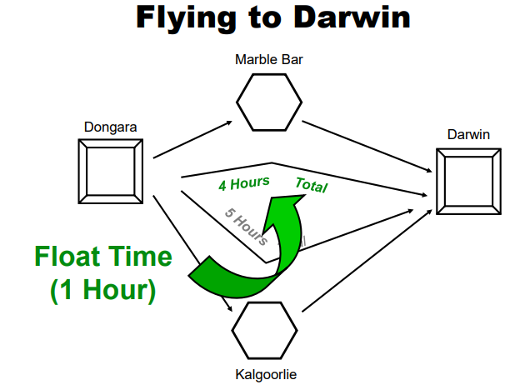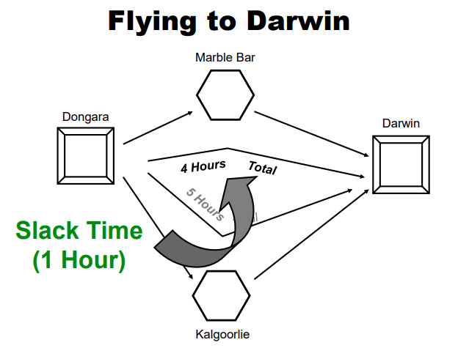

Critical Path: Generally, but not always, the sequence of schedule activities that determines the duration of the project. It is the longest path through the project.

Float Time

* Total Float Time (Slack Time): The total amount of time a schedule activity may be delayed from its early start date without delaying the project finish date or violating a schedule constraint.
* Free Float: The total amount of time a schedule activity can be delayed without delaying the early start of any immediately following schedule activities.

What Does a Schedule Look Like?

* Gantt Chart
* Network Diagram

They both show the same basic information in different ways.

Project Diagrams

* Gantt Chart
* Network Diagram
  + AOA (Activity On Arrow)
  + AON (Activity On Node)
  + PERT Chart (an early AON Diagram)
* CPM (Critical Path Method)

The Project Schedule

* Tasks across a timeline
* Road map
  + Project
  + Project Manager
  + Customers and stakeholders
* Communication tool
* Tracking tool

**Human Resources**

Two Categories

1. Determining the human resource requirements for the project and then getting them
2. Managing and leading the project team during the project

Work and Duration

Two key factors in determining the human resource needs for the project are:

* Work (or Effort)
* Duration

Work = Effort = Work Effort

Work Effort: The number of labor units required to complete a schedule activity or work breakdown structure component, often expressed in hours, days, or weeks.

Duration: The total number of work periods (not including holidays or other nonworking periods) required to complete a schedule activity or work breakdown structure component. Usually expressed as work days or work weeks. Sometimes incorrectly equated with elapsed time.

Putting the Full Team Together

* Recruiting/assigning team members
* Working with the functional managers

Team Kick-off Meeting

* Introduce team members
* Clarify the project mission, definition, deliverables
* Answer questions
* Clarify or start developing the project plan

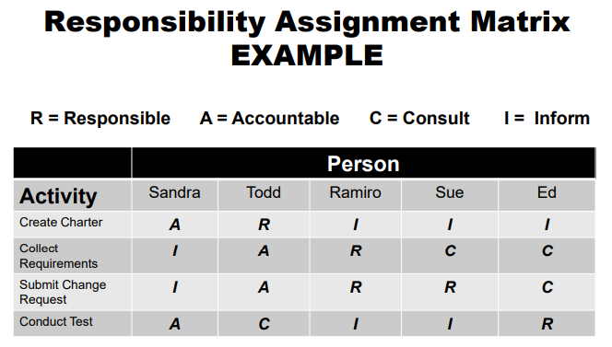

Scheduling Yourself as a Resource

* Changing roles
* Personal time management

**Leading and Managing the Team**

Why Delegating Might be Difficult

* The project manager may not believe the team members can complete the assigned tasks
* The project manager does not want to take the time to train team members
* The project manager is egotistical

Why Team Members May Not Want Delegation

* There are no rewards
* Are insecure
* Do not have the skills
* Simply don’t want to do the task
* Don’t trust the project manager or the organization

Evaluating team members’ ability to accept delegation:

1. Daily job duties
2. Special skills
3. Unique background or education
4. History of receiving delegated tasks
5. Willingness to accept delegated tasks
6. Willingness to accept training and guidance
7. Previous experience on a project team
8. Overall level of self-confidence
9. Typical level of response to being monitored
10. Personal ambitions and desires

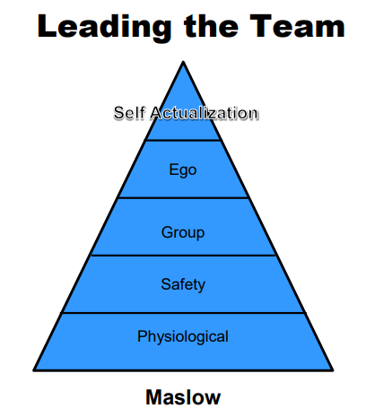

**Executing**

There May Be a Reason for “Faster” and “Cheaper”

* Meet deadline
* Increase profit margins
* Get to market before a competitor
* Longer project life cycle
* Take advantage of a time-limited opportunity
* Many others

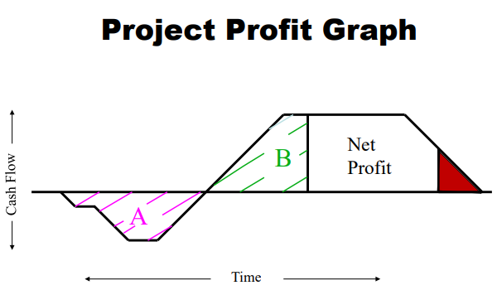

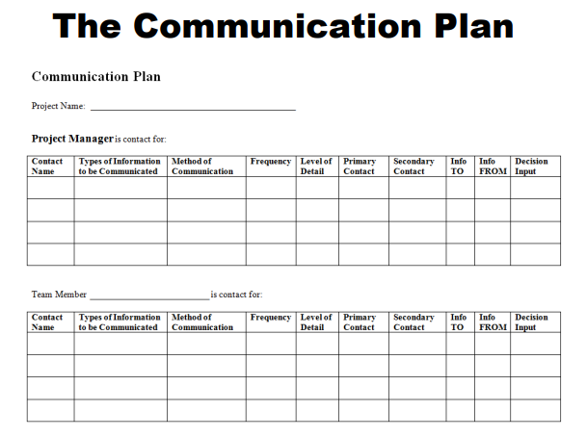

**Monitoring and Controlling**

Controlling: The Monitoring and Controlling Process Group consists of those processes required to track, review, and regulate the progress and performance of the project, identify any areas in which changes to the plan are required, and initiate the corresponding changes.

Track and Control the Project

* Monitor
* Evaluate
* Take controlling actions
* Successfully deliver results

Tracking Requires Two Tools

1. A project schedule to tell you where you should be with the project
2. A communication plan to tell you where you actually are with the project

Communication is Essential to Success

* Who needs to be in the communication loops?
* Why do they need to be in the loops?
* How can the project manager keep people informed and involved?

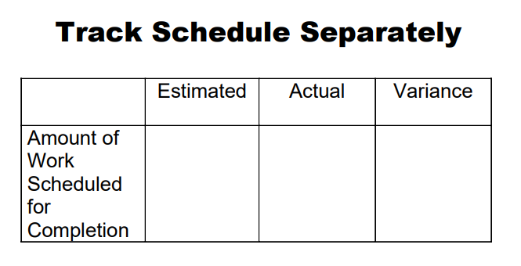

Earned Value Management: A tool that shows both SPENDING and PROGRESS on the same chart

Tracking the Project: To track the project, compare where the project is at any given point with where it should be at that point.

1. How much work is scheduled to be completed at this point compared with how much has actually been completed (SV or SPI)
2. How much money is budgeted to be spent at this point compared with how much has actually been spent (CV or CPI)

If You Are Using Earned Value Management

To track the project you compare:

1. How much work is scheduled to be completed at this point (PV) compared with how much has actually been completed (EV)

2. How much money is budgeted to be spent for this amount of completed work (EV) compared with how much has actually been spent (AC)

What if it Goes off Track?

Check the:

* S,Q,C,T targets
* Strategy
* Estimates
* Reporting of schedule and spending
* Human elements
  + your team
  + the organization
  + the customer
  + other stakeholders

Do something to fix it:

* Monitor the project
* Evaluate what is happening and determine why
* Take controlling actions
* On the task and technical side
* On the human dynamics side
* Successfully deliver results

Crashing the Project: A specific type of project schedule compression technique … to decrease the total project schedule duration…Typical approaches …include reducing schedule activity durations and increasing assignment of resources. Crashing often increases project costs.

Fast Tracking the Project: A specific type of project schedule compression technique that changes network logic to overlap phases that would normally be done in sequence…or to perform schedule activities in parallel. Fast Tracking often increases risks.

Reduce the Scope

The possibility to reduce the scope of the project is always present. This option might not be available to us because of stakeholder demands. With this option we simply remove some elements from the project and do not provide those related deliverables. Project managers cannot do magic. Projects have to obey the laws of the physical universe. So consider: crashing, fast tracking, or reducing scope.

It all goes back to the S,Q,C,T targets and the strategy

1. Lower the quality to reduce task durations or eliminate tasks
2. Reduce the scope
3. Increase the budget
4. Develop a new strategy
5. Replace team members
6. Anything else you can imagine

If Expectations Change (and they will)

* Refocus the customer or stakeholder
* Adjust the project (scope change)
* Re-define the project
* S,Q,C,T targets and relationships
* Strategy

**Closing**

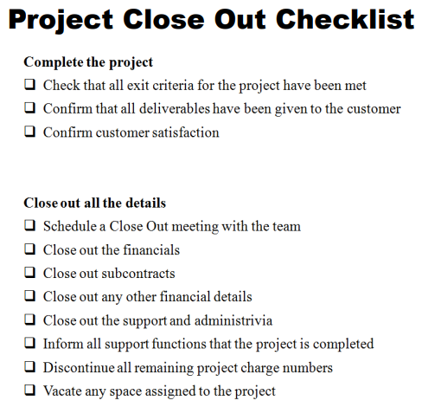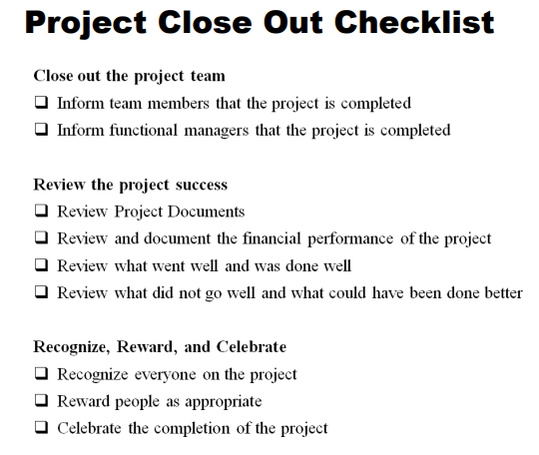

**Project Teamwork**

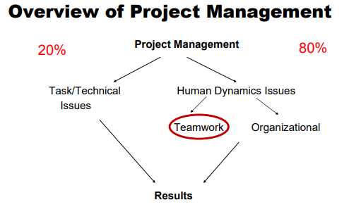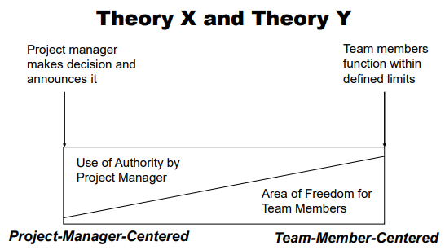

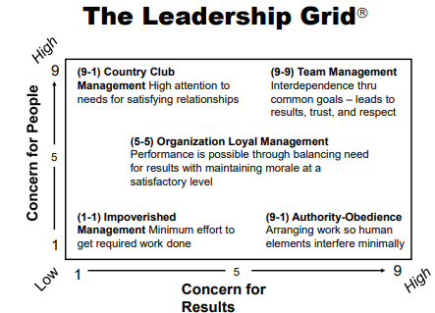

Three Key Elements: Wong

• Content • Process • Behavior

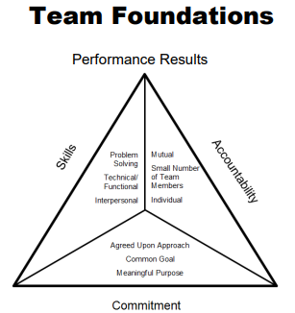

Processes

How will the team:

* Communicate
* Solve problems
* Generate ideas
* Be creative
* Manage difficult issues
* Share responsibility
* Make hand-offs from one team member to another

Two Ways to Set Project Goals

1. When the project is created, by the customers or other stakeholders, or when goals are implied by the nature of the project
2. The project team identifies and sets the project goals

Roles and Duties of the Project Manager

* Clarification of the project
  + Results
  + Deliverables
* Clarification of roles
  + Project manager or team leader
  + Team members
  + Others
* Bring the team together
* Managing the teamwork throughout the project

Duties, Roles, Responsibilities

* Do the project
* Complete the project tasks
* Collaborate
* Communicate
* Show respect
* Share information, ideas, opinions
* Solve problems
* Make decisions

Organizational Issues and Communication

* Who needs to be in the communication loops?
* Why do they need to be in the loop?
* How can the PM keep people informed?

Team Communication Issues

* Communication from the team to you
* Communication from you to your team

Principles of Verbal Communication

1. One-Way Communication • Encode • Transmit • Receive • Decode
2. Two-Way Communication • Encode • Transmit • Receive • Decode • Feedback

Stages of Team Development

* Forming: Information
* Storming: Adjustment
* Norming: Challenge them to think deeper
* Performing: Support

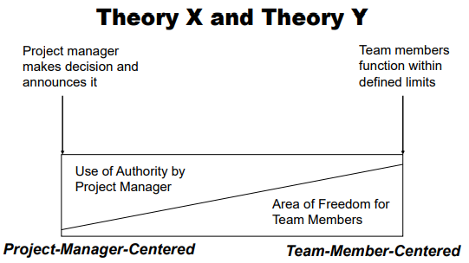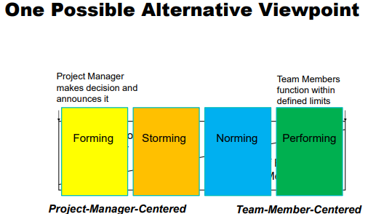

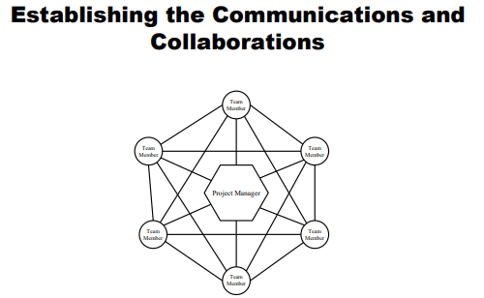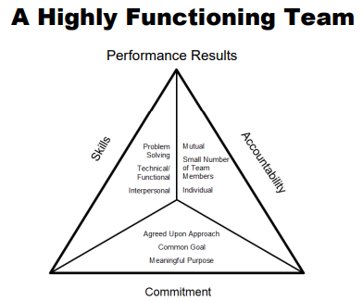

Radar Dysfunctional Team Behaviors

* Ignoring others
* Having side conversations
* Distracting
* Withdrawing
* Dominating
* Stating opinion as fact

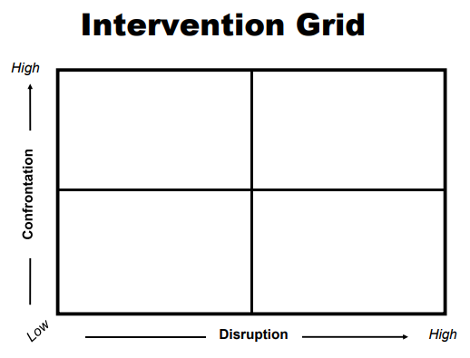

Seven Step Feedback Model

1. When you…
2. I feel…
3. Because…
4. Pause for a response (Optional)
5. What I would like is…
6. Because…
7. What do you think?

Six Other Ways To Deal With Difficult Stakeholders

* Reciprocity
* Scarcity
* Authority
* Consistency
* Liking
* Consensus

Reciprocity: Others will do things for us if we have first done things for them.

Scarcity: What you do for this stakeholder must be seen as: ♣ Beneficial ♣ Unique The stakeholder must also understand what they can potentially lose.

Authority: If you are seen as not just the person with “authority,” but as an authority or expert on what you are attempting to do in the project, people are more likely to agree with you and support what you are doing.

Consistency

* Consistency throughout the project in how things are done
* Consistency in how the project integrates with and adheres to organizational processes, procedures, guidelines, and policies
* Both of these can help deal with difficult Stakeholders.

Liking: People will agree more often with people they like. Take the time to build positive relationships with stakeholders.

Consensus: As it is within the team, listening to all viewpoints and building consensus on which is the best idea or action that will help the project move forward is also important to stakeholders.